Archery Equipment Examples for 2026 AIHEC
Figures 1, 2, & 3 show examples of bows that are acceptable.
Figure 1: Shows a wood laminate limb.
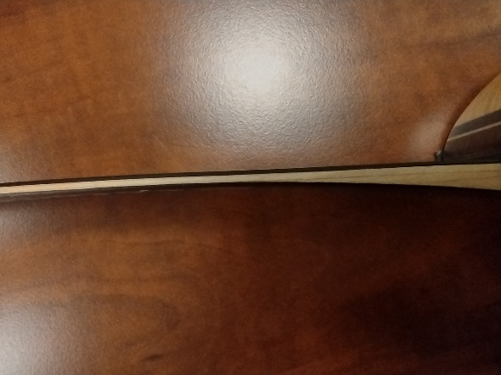
Figure 2: Illustrates a wood riser.
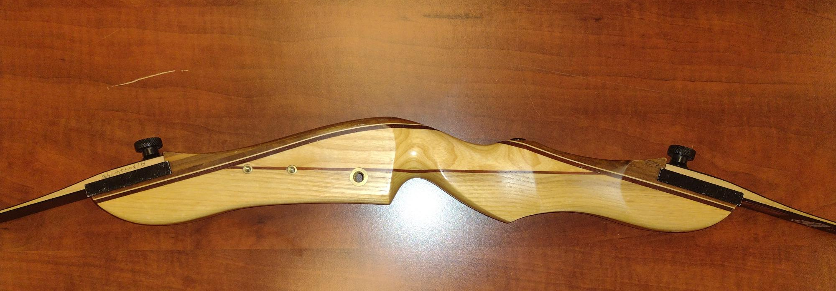
Figure 3: Shows the wood riser and wood laminate limbs.
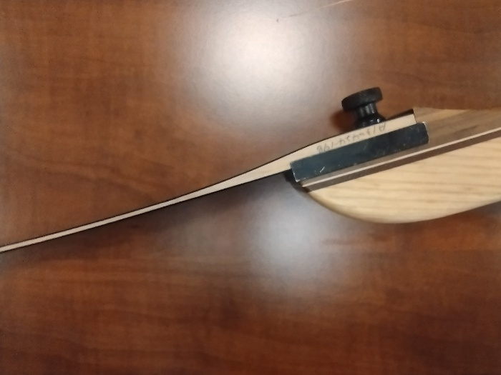

Figures 4 & 5 are examples of bows that are not acceptable for AIHEC competition.
Figure 4: Sows bows with aluminum riser and carbon limbs.
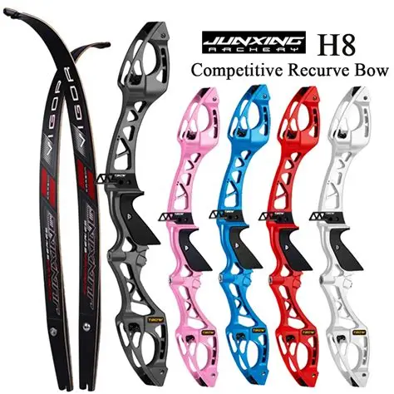

Figure 5: Illustrates carbon limbs.
